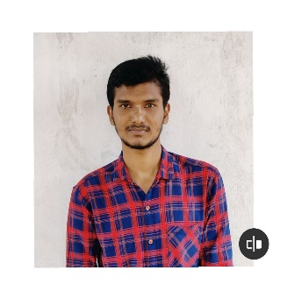KUMAR V B

Junior Software Engineer

Ph no:-9739326132

[**kumar.vb@brigosha.com**](mailto:kumar.vb@brigosha.com)

# OBJECTIVE

To evolve into a capable professional by being associated with a company that will challenge me to push my boundaries and allow me to use my education and skills in a way that is mutually beneﬁcial for my employer and me and achieve a sustainable growth in life.

# TRAINING SUMMARY

* Automotive Software Development Life Cycle Overview and Process.
* AUTOSAR Overview.
* Automotive E/E Architecture and systems.
* CANoe, CAPL and UDS.
* Embedded C and Hands-on Experience on PIC18F458
* Conﬁguration Management Tools - GitHub.
* Software Testing Process and its life cycle.

# TECHNICAL SUMMARY

* Programming Languages: C, CAPL, Embedded C.
* Tools: MS. Oﬃce, CANoe tool, KEIL, MPLABXIDE, CAN Analyzer, Code blocks.
* Protocols: CAN.
* Operating System: Windows
* Microcontroller: 8051, PIC18F458.

# EXPERIENCE

**Brigosha Technologies Pvt Ltd, Bengaluru** *- Junior Software Engineer in Embedded*

AUGUST 2022 - PRESENT

# EDUCATION

|  |  |  |  |  |  |
| --- | --- | --- | --- | --- | --- |
| **Qualiﬁcatio n College / School** | **College / School** | **Name University/Board** | **Year of Passing (YoP)** | **Branch / Stream** | **Percentage (%)** |
| B.E | JNN College of Engineering Shivamogga. | Visvesvaraya Technological University | 2022 | Electronics and Communication | 7.02(CGPA) |
| PUC | Acharya PU College Shivamogga. | Karnataka PU Board | 2018 | PCMB | 65.5 |
| SSLC | Morarji Desai Residential School,Honnali. | Karnataka Secondary Examination Board | 2016 |  | 83.2 |

# PROJECT DETAILS:

## Academic Project 1: intelligent System Based Automatic Predication Of Drought Using Satellite Images.

* The project will help us know that we need to extract information from satellite rather the using metrogical data.
* It can be predicated and good example for long range.it combines the current drought level with the predication of environment.
* **Role**: Building of schematics and implementing the same.

## Industry Project 1: Wiper and Washer.

* Wiper is used to clean the window which we controlled in this project using the hardware switches and washer is controlled by using the CAN message we send in the bus master.
* Tools :MPLABXIDE,CAN analyzer.
* **Role**: As a Team member Worked on Programming.

# ADDITIONAL SKILLS:

* Fast Learner.
* Team-Worker with Leadership Qulaities.
* Good Communication.
* Creative Organisation of Resources.

**PERSONAL ADDRESS:**

Chatnhalli,Chatnhalli(post),Naymthi(TQ),

Davangere(D),Karanataka,577225.

Declaration: -

I hereby declare that the details and information given above are complete and true to the best of my knowledge.

Place: Bangalore

Date :16-01-2023 Kumar V B